**Open Source Tools**  
GA.2246-001: Spring 2017

Project Report

By

Shubham Jain

NYU ID: N19444780

Net ID: sj2180

Resource Creation & Reservation

URL : <https://resource-reservation-sj2180.appspot.com/>

To access the app, it is required to sign in using a google account.

* 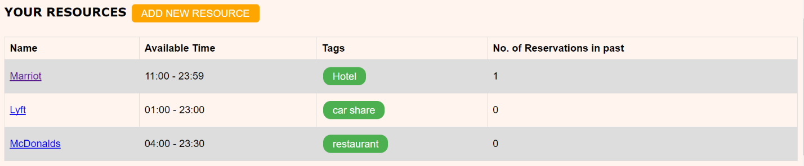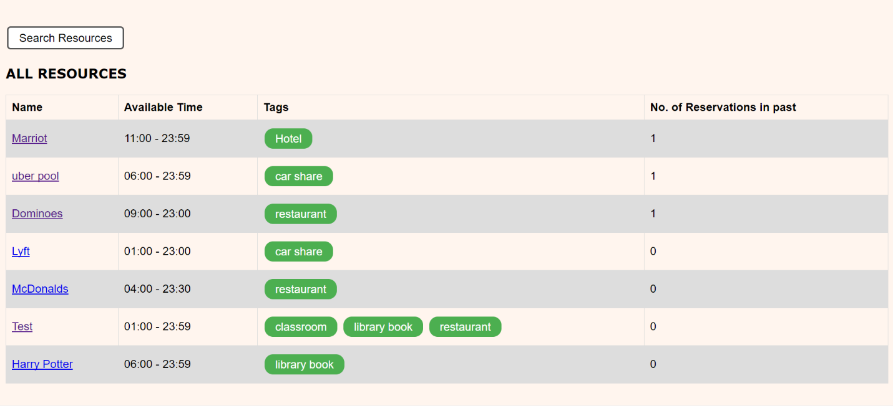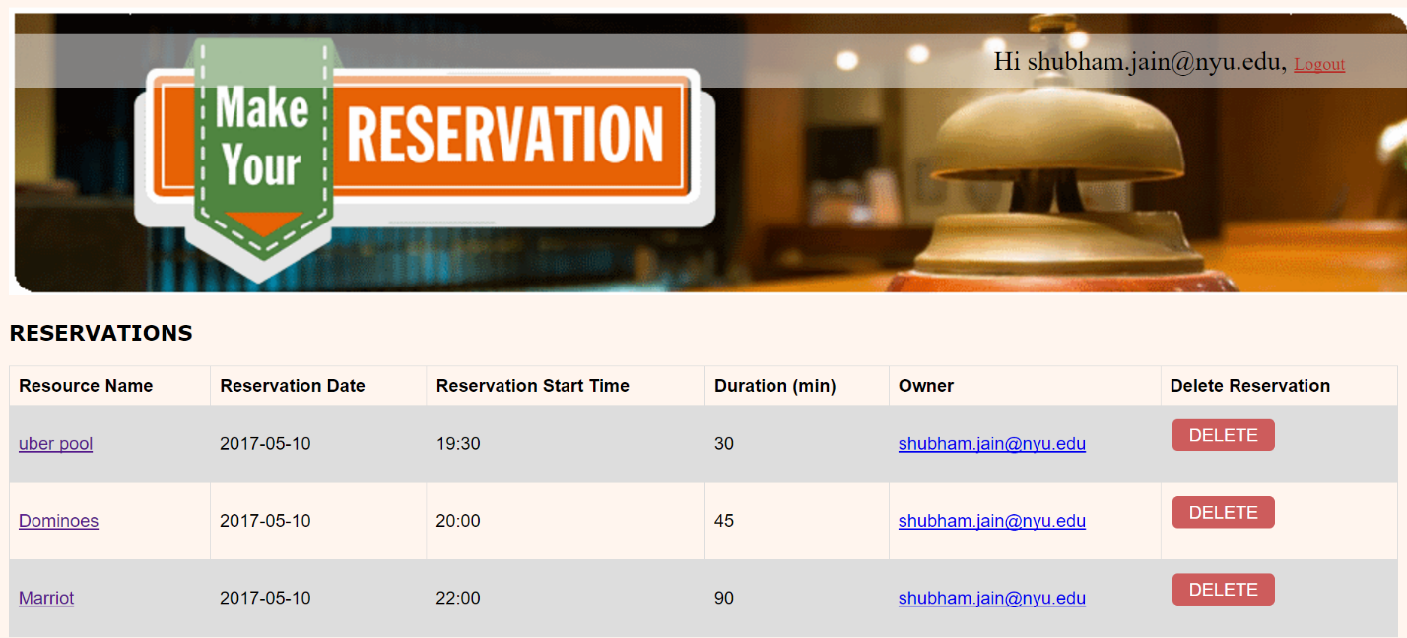**LANDING PAGE**

**Features:**

* Three Sections
  + Reservations made for resources by the logged in user, sorted by Reservation Start time. Once the end time for a reservation has passed, it is not shown anymore in any view. Functionality to delete a reservation is also present.
  + All resources in the system, shown in reverse time order based on last made reservation.
  + Resources that the logged in user owns, each linked to its URL, shown in reverse time order based on last made reservation.
    - Wherever the resource name is present on the app, its linked to its URL. The information present on its page is described in below sections.
    - There is an account of the no. of reservations done on that resource in the past. If a reservation is made, the value is incremented. If a reservation is deleted, this value is decremented by 1.
    - More information on other fields like Tags is described in the following sections.
* There is an “Add a New Resource” button for adding new resources. More information on this in the following section.
* There is a “Search” functionality present. Details ahead.
* The owner of the reservation also has his/her own page showing more information such as the resources created by that user, all upcoming reservations for that user, etc. More described in below sections.
* **ADD NEW RESOURCE** (When ‘ADD NEW RESOURCE’ is clicked)

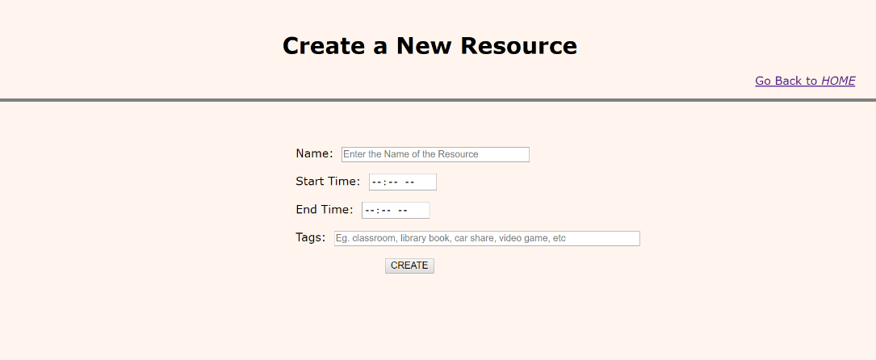

**Features:**

* Fields:
  + Name of the Resource (should be unique).
  + Start Time & End Time. These fields specify the availability of the resource. You can specify the time in 12 hour format (AM/PM).
  + Tags – The user can specify 0 or more tags (comma separated). These are arbitrary strings, e.g. *restaurant* or *room*.
  + Create Button – Once the above information is validated, the resource is added and is shown on the lading page under ‘All Resources’ and ‘Your Resources’. ‘resourceReservedAt’ value is set to None.
  + A Link to go back to the Landing Page.
* Validation
  + Start Time should not be more than the End time!
  + 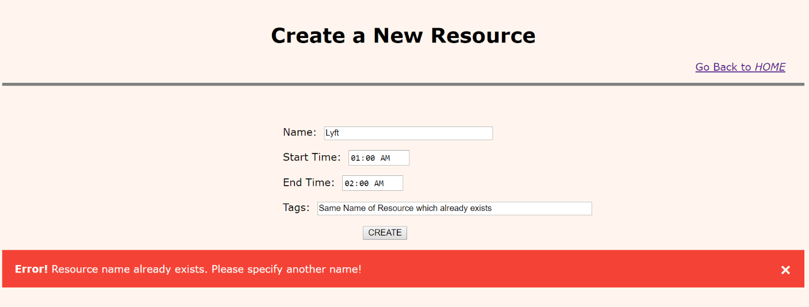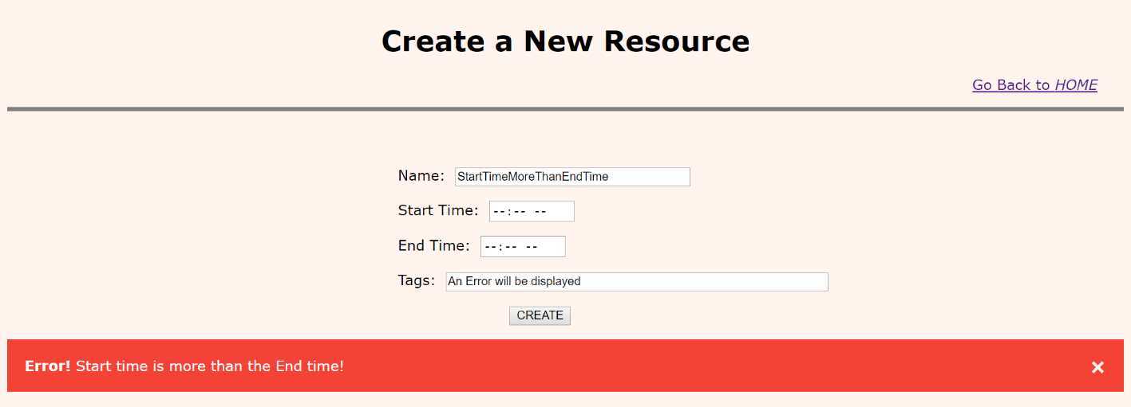Resource Name should be unique!

**RESOURCE PAGE** (When a Resource Name is clicked)

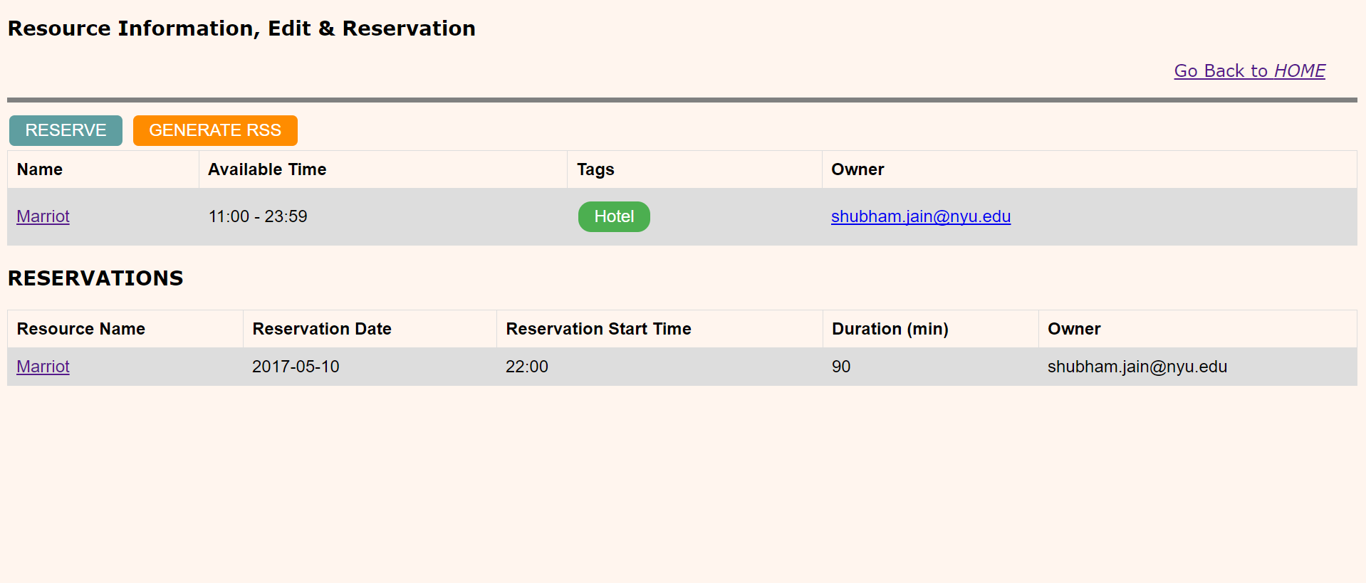

**Features**

* This page displays all the information related to a resource.
  + Name of the Resource
  + Its availability
  + Tags associated with this resource
  + Owner of the reource
  + All the reservations done on this resource and the information related to the reservation (as shown in figure above).
* There are 3 button available
  + EDIT RESOURCE
    - Only visible if the user who created this resource is viewing this resource.
    - If a reservation is done on this resource, Editing the resource is not allowed until the reservation is deleted or completed.
    - If the button is visible, the user can click on it and it will take them to the edit resource page described ahead in documentation.
  + RESERVE
    - Visible to everyone. If clicked, the user is directed to the reserve resource page described ahead in documentatio.
  + GENERATE RSS
    - Visible to everyone. If clicked, it directs the user to the RSS page, where the reservation information for that resource is dumped in the XML format. If there is no reservation, the XML format states that. More information on this in the documentation ahead.

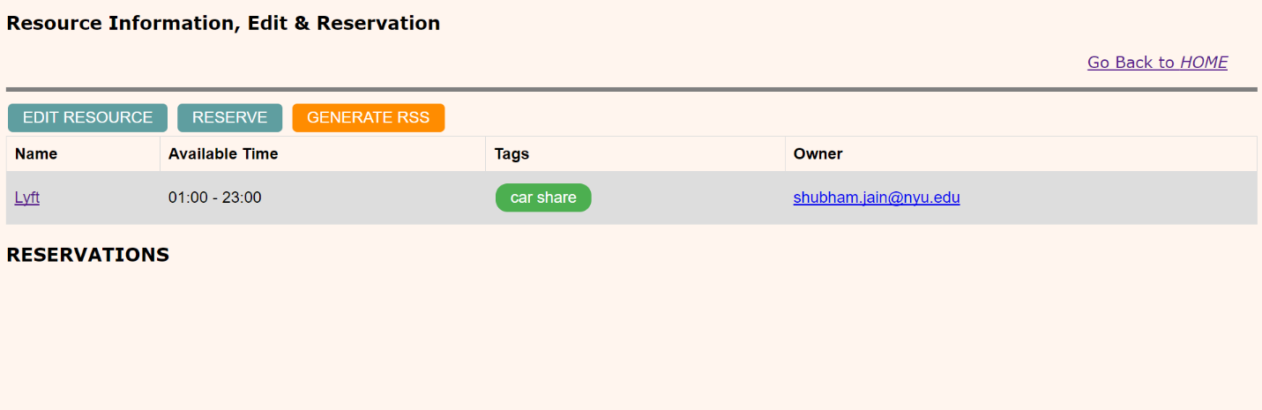

**EDIT RESOURCE** (When “EDIT RESOURCE” button on the resource info page is clicked)

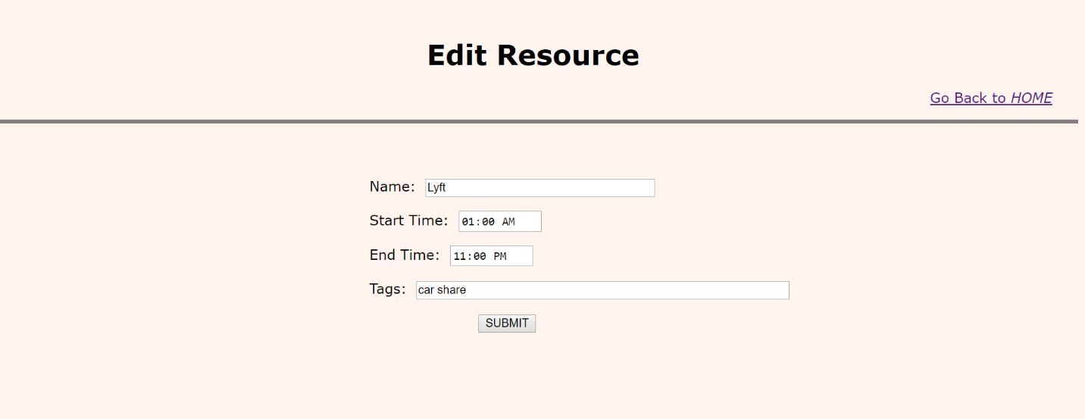

**Features:**

* This page allows to edit resource’s information.
* When editing, the previously entered information about the resources is shown in the form as default values.
* Fields:
  + Name of the Resource (should be unique).
  + Start Time & End Time. These fields specify the availability of the resource. You can specify the time in 12 hour format (AM/PM).
  + Tags – The user can specify 0 or more tags (comma separated). These are arbitrary strings, e.g. *restaurant* or *room*.
  + Submit Button – Once the above information is validated, the resource is edited and is shown on the lading page under ‘All Resources’ and ‘Your Resources’. The resource is updated in the data store as well.
  + A Link to go back to the Landing Page.
* Validation
  + Start Time should not be more than the End time!
  + Name of the resource should be unique.

**RESERVE A RESOURCE** (When “RESERVE” button on the resource info page is clicked)

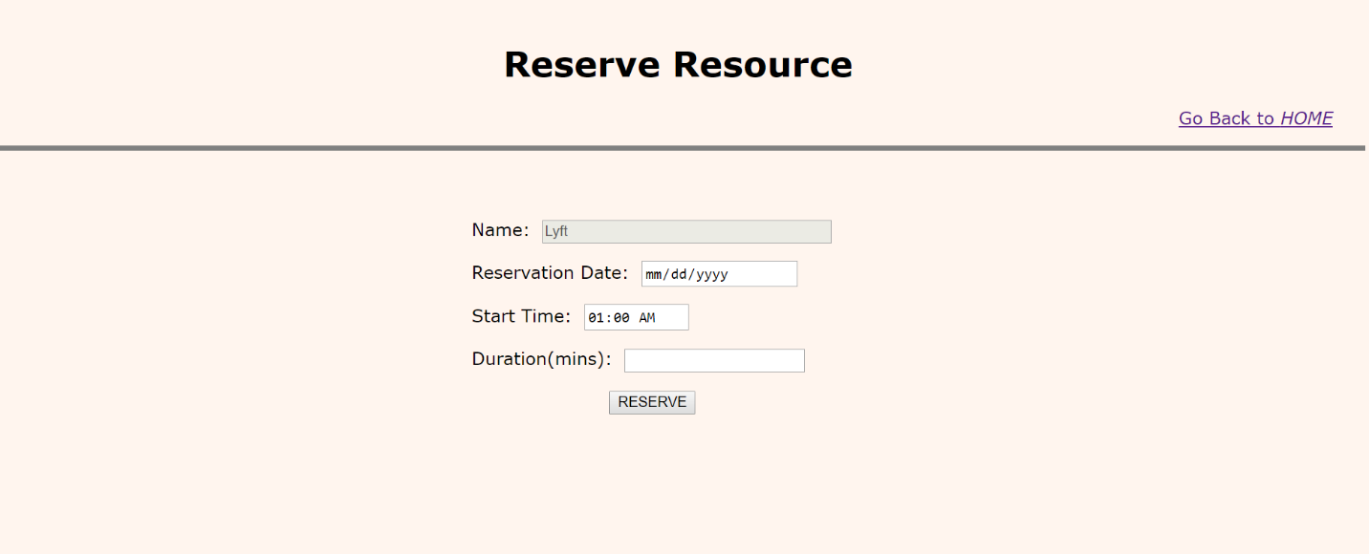

**Features**

* Anyone can reserve a resource no matter who is the owner.
* Fields:
  + Name of the Resource: The user cannot edit the name of the resource he/she is reserving.
  + Reservation Date: In the format of mm/dd/yyyy
  + Start Time: Start time of the reservation. 12 hour format (AM/PM)
  + Duration: Duration of the reservation in minutes.
  + Reserve Button: If all the above fields are valid (below), a reservation entry is shown on the landing page.
* Validations:
  + 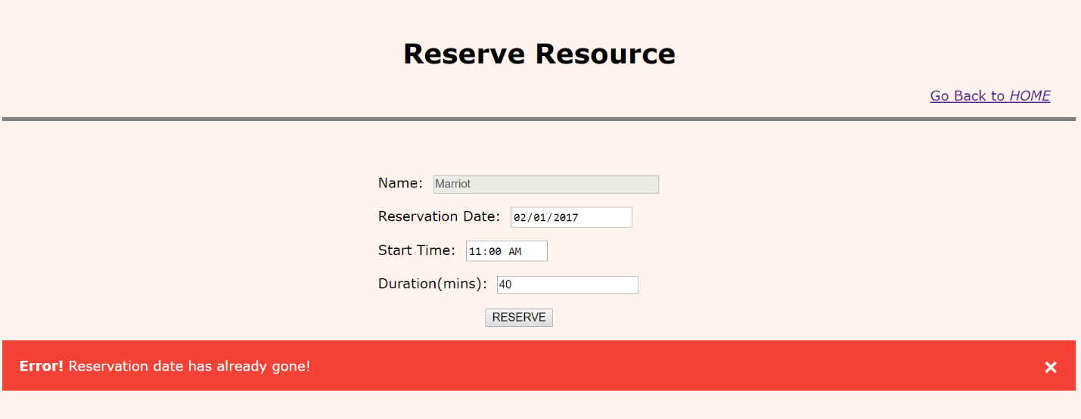Reservation Date has to be either the day on which the app is visited or any day in future. User is not allowed to make a reservation on a past date.
  + Start Time of the reservation has to be equal to or more than the current time if reservation is today.

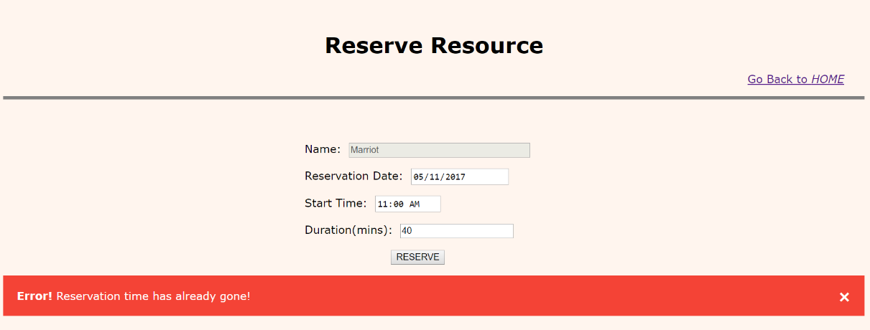

**RSS INFORMATION**

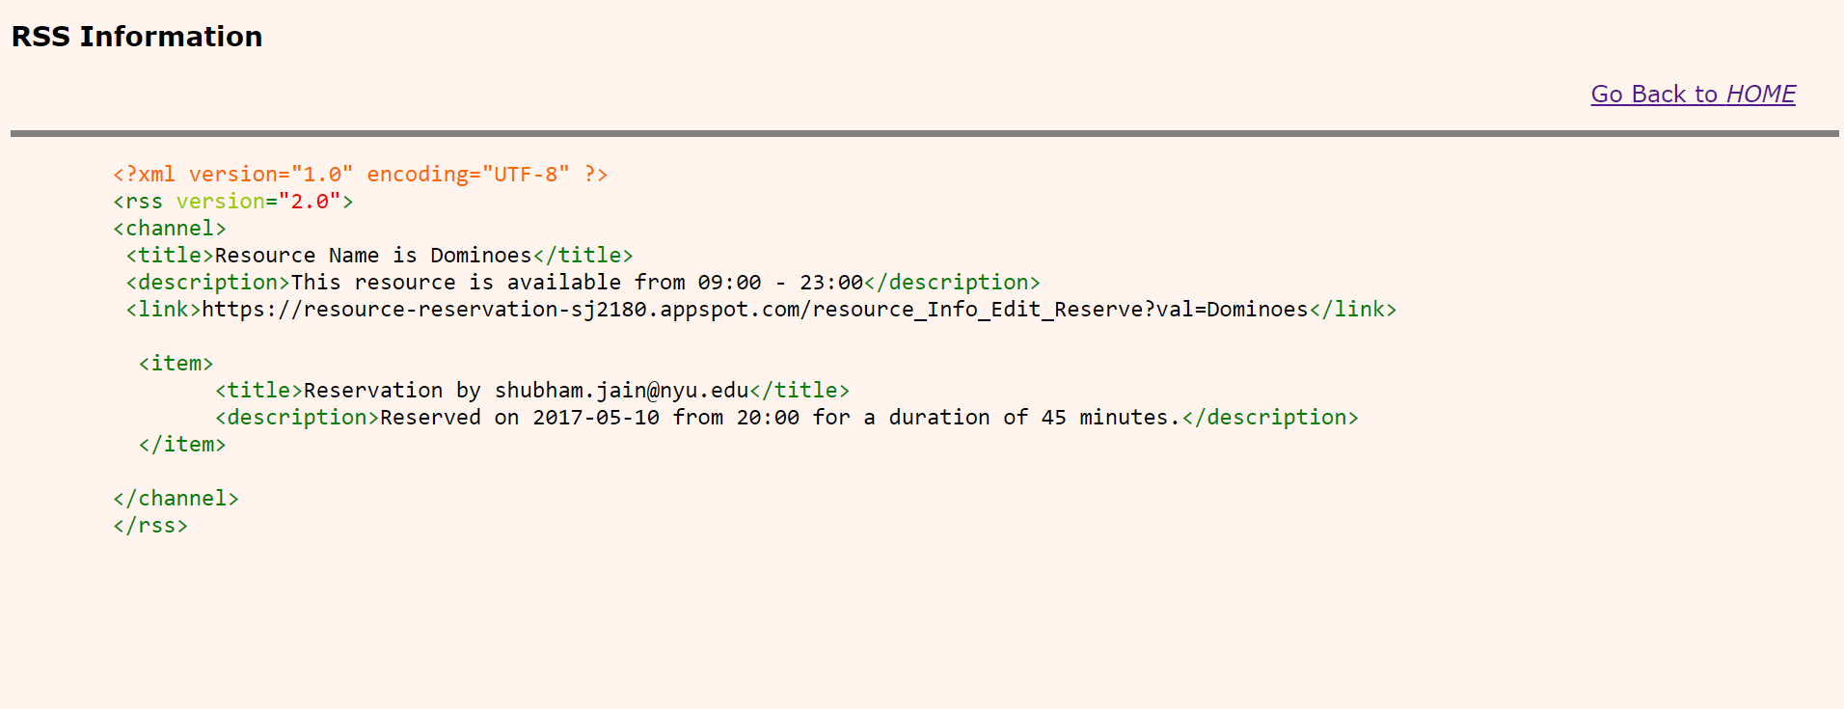

**TAG Page**

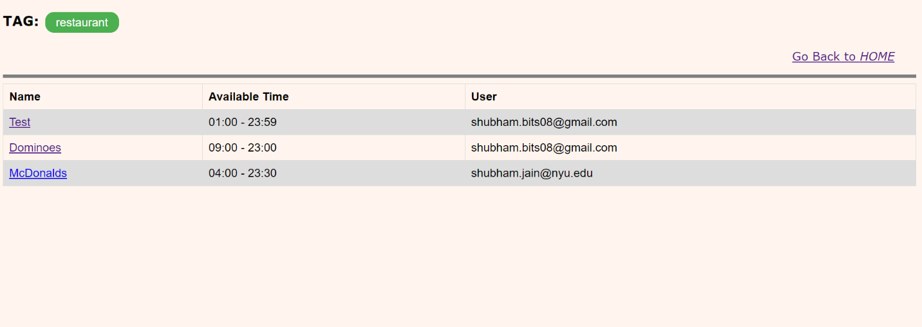

**USER INFORMATION**

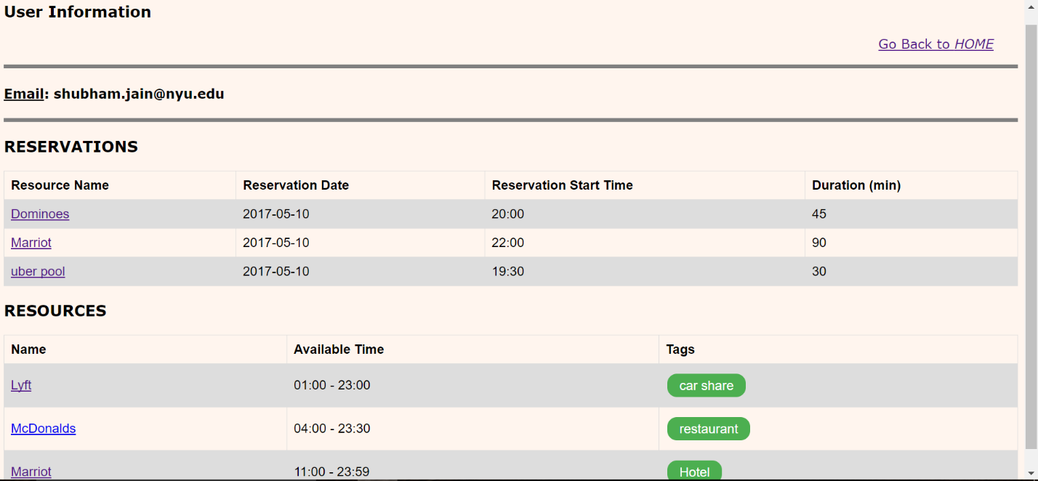

**SEARCH**

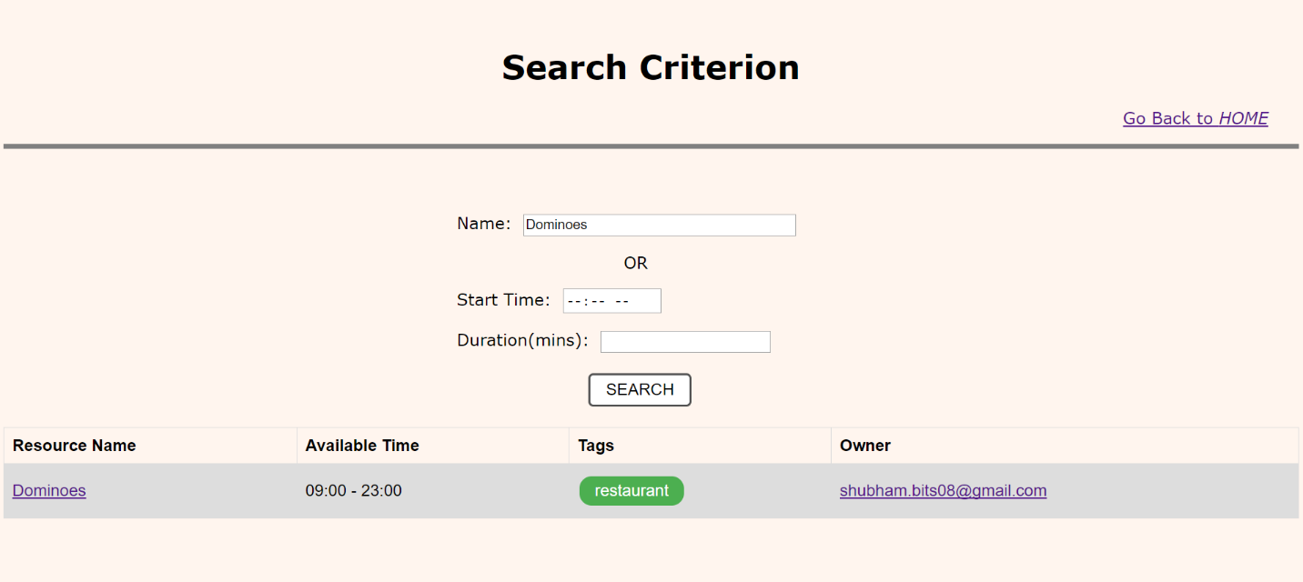

**EMAIL Confirmation**

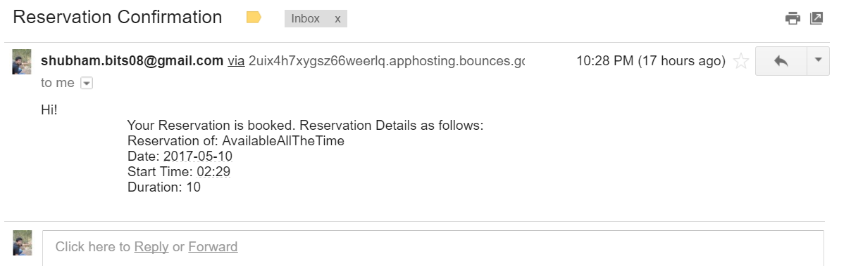

**CODE DESIGN**